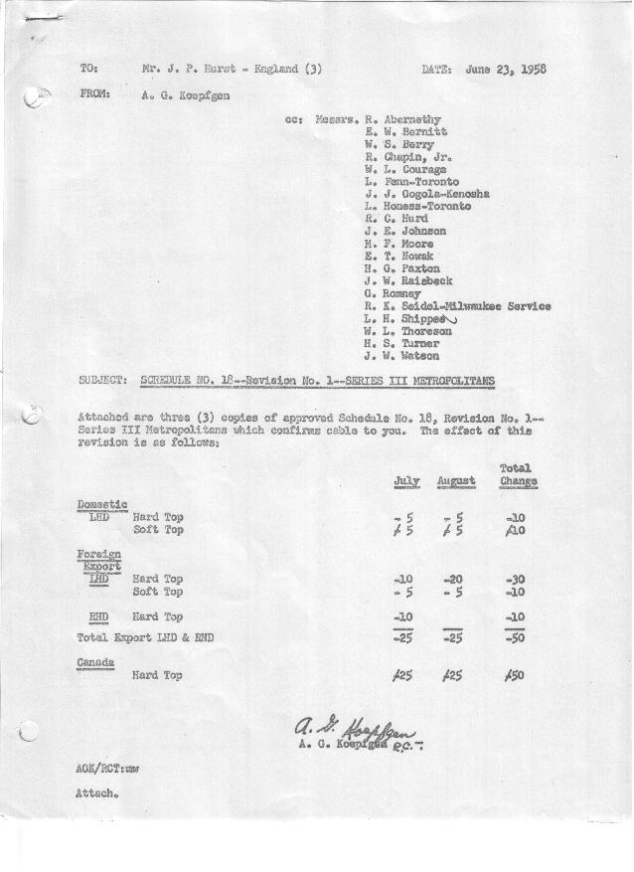

FORM AM 1262 Page 1 of 2 APPROVED R. Abernethy DATE 6/23/58

SCHEDULE NO. ______18 ___ DATE 5-21-58 MONTHLY BUILDING SCHEDULE APPROVED E.W.Bernitt (signed) ___ _DATE_ 6/23/58 _
REVISION NO. _______ 1 ______ DATE 6-23-58 PRODUCT APPROVED R. W.Chapin Jr. DATE _ 6/23/58 ____
SERIES III 1500 c.c. ENGINE
METROPOLITAN SERIES CARS – AUSTIN MOTORS CO., LTD, ENGLAND
DESCRIPTION | BUILT  ◻ACT EST  THRU  APRIL | FIRM BUILDING SCHEDULE  (FABRICATED MATERIAL RELEASE) |  |  |  |  |  |  |  |  |  |  |  |  |  |  | TENTATIVE SCHEDULE  (RAW MATERIAL RELEASED) |  |  | GRAND  TOTAL
DESCRIPTION | BUILT  ◻ACT EST  THRU  APRIL | MONTH May  DAYS 20 |  |  | MONTH June  DAYS 21 |  |  | MONTH July  DAYS 19 |  |  | MONTH August  DAYS 15 |  |  | MONTH September  DAYS 22 |  |  | MONTH October  DAYS 23 |  |  | GRAND  TOTAL
DESCRIPTION | BUILT  ◻ACT EST  THRU  APRIL | DAILY | MONTH | CUM’L  TOTAL | DAILY | MONTH | CUM’L  TOTAL | DAILY | MONTH | CUM’L  TOTAL | DAILY | MONTH | CUM’L  TOTAL | DAILY | MONTH | CUM’L  TOTAL | DAILY | MONTH | CUM’L TOTAL | GRAND  TOTAL
DOMESTIC LHD:
Hard-Top | 21637 |  | 568 | 22205 |  | 509 | 22714 |  | 878 | 23592 |  | 687 | 24279 |  | 983 | 25262 |  | 1054 | 26316
Soft-Top | 3495 |  | 199 | 3694 |  | 121 | 3815 |  | 125 | 3940 |  | 99 | 4039 |  | 121 | 4160 |  | 117 | 4277
Total U.S. | 25132 | 38.3 | 767 | 25899 | 30.0 | 630 | 26529 | 52.8 | 1003 | 27532 | 52.4 | 786 | 28318 | 50.2 | 1104 | 29422 | 50.9 | 1171 | 30593
Over/(Under) Schedule 18 | -0- |  | -0- | -0- |  | -0- | -0- |  | -0- | -0- |  | -0- | -0- |  | -0- | -0- |  | -0- | -0-
FOREIGN:
EXPORT LHD Hard-Top | 704 |  | 25 | 729 |  | 35 | 764 |  | 25 | 789 |  | 15 | 804 |  | 35 | 839 |  | 35 | 874
Soft-Top | 327 |  | 12 | 339 |  | 15 | 354 |  | 10 | 364 |  | 10 | 374 |  | 15 | 389 |  | 15 | 404
Total Export LHD | 1031 |  | 37 | 1068 |  | 50 | 1118 |  | 35 | 1153 |  | 25 | 1178 |  | 50 | 1228 |  | 50 | 1278
RHD Hard Top | 343 |  | 13 | 356 |  | 12 | 368 |  | 10 | 378 |  | 12 | 390 |  | 20 | 410 |  | 12 | 422
Soft Top | 58 |  | 4 | 62 |  | 3 | 65 |  | 5 | 70 |  | 3 | 73 |  | 5 | 78 |  | 3 | 81
Total Export RHD | 401 |  | 17 | 418 |  | 15 | 433 |  | 15 | 448 |  | 15 | 463 |  | 25 | 488 |  | 15 | 503
Total Export LHD & RHD | 1432 | 2.7 | 54 | 1486 | 3.1 | 65 | 1551 | 2.6 | 50 | 1601 | 2.7 | 40 | 1641 | 3.4 | 75 | 1716 | 2.8 | 65 | 1781
Over/(Under) Schedule 18 | -0- |  | -0- | -0- |  | -0- | -0- |  | (25) | (25) |  | (25) | (50) |  | -0- | (50) |  | -0- | (50)
CANADA Hard-Top | 2287 |  | 51 | 2338 |  | 52 | 2390 |  | 25 | 2415 |  | 25 | 2440 |  | 70 | 2510 |  | 70 | 2580
Soft-Top | 209 |  | 22 | 231 |  | 9 | 240 |  | -0- | 240 |  | -0- | 240 |  | -0- | 240 |  | -0- | 240
Total Canada | 2496 | 3.7 | 73 | 2569 | 2.9 | 61 | 2630 | 1.3 | 25 | 2655 | 1.7 | 25 | 2680 | 3.2 | 70 | 2750 | 3.1 | 70 | 2820
Over/(Under) Schedule 18 | -0- |  | -0- | -0- |  | -0- | -0- |  | 25 | 25 |  | 25 | 50 |  | -0- | 50 |  | -0- | 50
Total Foreign | 3928 | 6.4 | 127 | 4055 | 6.0 | 126 | 4181 | 3.9 | 75 | 4256 | 4.3 | 65 | 4321 | 6.6 | 145 | 4466 | 5.9 | 135 | 4601
Over/(Under) Schedule 18 | -0- |  | -0- | -0- |  | -0- | -0- |  | -0- | -0- |  | -0- | -0- |  | -0- | -0- |  | -0- | -0-
GRAND TOTALS
Hard-Top | 24971 | 32.9 | 657 | 25628 | 29.0 | 608 | 26236 | 49.3 | 938 | 27174 | 49.3 | 739 | 27913 | 50.4 | 1108 | 29021 | 50.9 | 1171 | 30192
Soft-Top | 4089 | 11.8 | 237 | 4326 | 7.0 | 148 | 4474 | 7.4 | 140 | 4614 | 7.4 | 112 | 4726 | 6.4 | 141 | 4867 | 5.9 | 135 | 5002
Total | 29060 | 44.7 | 894 | 29954 | 36.0 | 756 | 30710 | 56.7 | 1078 | 31788 | 56.7 | 851 | 32639 | 56.8 | 1249 | 33888 | 56.8 | 1306 | 35194
Over/(Under) Schedule 18 | -0- |  | -0- | -0- |  | -0- | -0- |  | -0- | -0- |  | -0- | -0- |  | -0- | -0- |  | -0- | -0-

FORM AM 1262 Page 2 of 2 APPROVED R. Abernethy DATE 6/23/58

SCHEDULE NO. ______18 ___ DATE 5-21-58 MONTHLY BUILDING SCHEDULE APPROVED E.W.Bernitt (signed) ___ _DATE_ 6/23/58 _
REVISION NO. _______ 1 ______ DATE 6-23-58 PRODUCT APPROVED R. W.Chapin Jr. DATE _ 6/23/58 ____
SERIES III 1500 c.c. ENGINE
METROPOLITAN SERIES CARS – AUSTIN MOTORS CO., LTD, ENGLAND
DESCRIPTION | BUILT  ◻ACT◻ EST  THRU | FIRM BUILDING SCHEDULE  (FABRICATED MATERIAL RELEASE) |  |  |  |  |  |  |  |  |  |  |  |  |  |  | TENTATIVE SCHEDULE  (RAW MATERIAL RELEASED) |  |  | GRAND  TOTAL
DESCRIPTION | BUILT  ◻ACT◻ EST  THRU | MONTH November  DAYS 20 |  |  | MONTH December  DAYS 21 |  |  | MONTH January, 1959  DAYS 22 |  |  | MONTH February  DAYS 20 |  |  | MONTH March  DAYS 22 |  |  | MONTH April  DAYS 3 |  |  | GRAND  TOTAL
DESCRIPTION | BUILT  ◻ACT◻ EST  THRU | DAILY | MONTH | CUM’L  TOTAL | DAILY | MONTH | CUM’L  TOTAL | DAILY | MONTH | CUM’L  TOTAL | DAILY | MONTH | CUM’L  TOTAL | DAILY | MONTH | CUM’L  TOTAL | DAILY | MONTH | CUM’L TOTAL | GRAND  TOTAL
DOMESTIC LHD
Hard-Top |  |  | 585 | 26901 |  | 681 | 27582 |  | 688 | 28270 |  | 573 | 28843 |  | 880 | 29723 |  | 142 | 29865
Soft-Top |  |  | 65 | 4342 |  | 76 | 4418 |  | 94 | 4512 |  | 143 | 4655 |  | 220 | 4875 |  | 36 | 4911
Total U.S. |  | 32.5 | 650 | 31243 | 36.0 | 757 | 32000 | 35.5 | 782 | 32782 | 35.8 | 716 | 33498 | 50.0 | 1100 | 34598 | 59.1 | 178 | 34776
Over/(Under) Schedule 18 |  |  | -0- | -0- |  | -0- | -0- |  | -0- | -0- |  | -0- | -0- |  | -0- | -0- |  | -0- | -0-
FOREIGN:
EXPORT LHD Hard-Top |  |  | 35 | 909 |  | 35 | 944 |  | 35 | 979 |  | 35 | 1014 |  | 35 | 1049 |  | -0- | 1049
Soft-Top |  |  | 15 | 419 |  | 15 | 434 |  | 15 | 449 |  | 10 | 459 |  | 6 | 465 |  | -0- | 465
Total Export LHD |  |  | 50 | 1328 |  | 50 | 1378 |  | 50 | 1428 |  | 45 | 1473 |  | 41 | 1514 |  | -0- | 1514
RHD Hard Top |  |  | 20 | 442 |  | 12 | 454 |  | 20 | 474 |  | 12 | 486 |  | 20 | 506 |  | -0- | 506
Soft Top |  |  | 5 | 86 |  | 3 | 89 |  | 5 | 94 |  | 3 | 97 |  | 5 | 102 |  | -0- | 102
Total Export RHD |  |  | 25 | 528 |  | 15 | 543 |  | 25 | 568 |  | 15 | 583 |  | 25 | 608 |  | -0- | 608
Total Export LHD & RHD |  | 3.7 | 75 | 1856 | 3.1 | 65 | 1921 | 3.4 | 75 | 1996 | 3.0 | 60 | 2056 | 3.0 | 66 | 2122 |  | -0- | 2122
Over/(Under) Schedule 18 |  |  | -0- | (50) |  | -0- | (50) |  | -0- | (50) |  | -0- | (50) |  | -0- | (50) |  | -0- | (50)
CANADA Hard-Top |  |  | 77 | 2657 |  | 20 | 2677 |  | 15 | 2692 |  | 10 | 2702 |  | 85 | 2787 |  | -0- | 2787
Soft-Top |  |  | -0- | 240 |  | -0- | 240 |  | 10 | 250 |  | 15 | 265 |  | 50 | 315 |  | -0- | 315
Total Canada |  | 3.9 | 77 | 2897 | 1.0 | 20 | 2917 | 1.1 | 25 | 2942 | 1.3 | 25 | 2967 | 6.1 | 135 | 3102 |  | -0- | 3102
Over/(Under) Schedule 18 |  |  | -0- | 50 |  | -0- | 50 |  | -0- | 50 |  | -0- | 50 |  | -0- | 50 |  | -0- | 50
Total Foreign |  | 7.6 | 152 | 4753 | 4.1 | 85 | 4838 | 4.5 | 100 | 4938 | 4.3 | 85 | 5023 | 9.1 | 201 | 5224 |  | -0- | 5224
Over/(Under) Schedule 18 |  |  | -0- | -0- |  | -0- | -0- |  | -0- | -0- |  | -0- | -0- |  | -0- | -0- |  | -0- | -0-
GRAND TOTALS
Hard-Top |  | 35.8 | 717 | 30909 | 35.6 | 748 | 31657 | 34.5 | 758 | 32415 | 31.5 | 630 | 33045 | 46.3 | 1020 | 34065 | 47.1 | 142 | 34207
Soft-Top |  | 4.3 | 85 | 5087 | 4.5 | 94 | 5181 | 5.6 | 124 | 5305 | 8.6 | 171 | 5476 | 12.8 | 281 | 5757 | 12.0 | 36 | 5793
Total |  | 40.1 | 802 | 35996 | 40.1 | 842 | 36838 | 40.1 | 882 | 37720 | 40.1 | 801 | 38521 | 59.1 | 1301 | 39822 | 59.1 | 178 | 40000
Over/(Under) Schedule 18 |  |  | -0- | -0- |  | -0- | -0- |  | -0- | -0- |  | -0- | -0- |  | -0- | -0- |  | -0- | -0-

